AUTOMATIC RECOGNITION OF THE SOURCE OF TEMPOROMANDIBULAR JOINT SOUNDS
Dragan Djurdjanovic¹, Kok Hwee Koh¹, William J. Williams², Sven E. Widmalm³ and Yang Kok Pin¹
¹School of Mechanical and Production Engineering, Nanyang Technological University, Singapore
²Dept. of Electrical Engineering and Computer Science, University of Michigan, Ann Arbor, MI, USA
³School of Dentistry, University of Michigan, Ann Arbor, MI, USA

ABSTRACT
Sounds evoked in the temporomandibular joint (TMJ) during jaw movements may indicate pathology. They are in dental clinics usually recorded by auscultation and noted in protocols by verbal, subjective descriptions. Time-frequency analysis of electronically recorded TMJ sounds makes possible a more objective and sophisticated analysis. Such sounds were recorded from four subjects and grouped into two sets. One was used for training a classifier, while the other was used for testing its ability to relate a given sound to the subject from which it was recorded. Both scale and time-shift invariant representations, as well as only time-shift invariant representations of the Reduced Interference Distributions of the TMJ sounds were used for pattern recognition. The nearest neighbor, zero-subspace and nearest constrained linear combination classification methods were employed. It was observed that TMJ sound patterns could be very typical for a given person. This indicates that our classification approach can be developed into a useful diagnostic tool by obtaining training sets from patients where a definitive diagnosis of TMJ pathology has been obtained.
Keywords: Temporomandibular joint sounds, TMJ, Temporomandibular Joint Disorders, TMD, Reduced Interference Time-Frequency Distributions, RID, Scale and shift invariance, Pattern recognition.

1. INTRODUCTION
Temporomandibular joint (TMJ) sounds evoked during joint motion may indicate joint pathology [1]. They can be recorded by auscultation using a stethoscope and noted in a clinical protocol by verbal descriptions. Auscultatory findings are, however, subjective and cannot be used for reliable comparisons of diagnoses between clinicians, or within the same patient over time [2], [3]. Hence the significance of instead using electronic recording and advanced methods of time-frequency analysis.
Time-frequency analysis is a powerful tool in the analysis of non-stationary signals and has been proven efficient when applied to TMJ sounds. In [1] the Reduced Interference Time-Frequency Distributions (RIDs) [4] of TMJ sounds from 27 fresh autopsy specimens were analyzed by visual inspection and correlated to pathology findings. It was shown that presence of joint sounds was significantly associated with arthrosis of the articular surfaces. It was, however, clear that sounds may occur also in joints without pathosis. Therefore a more detailed classification of sounds, now possible by using time-frequency analysis, is needed to differ between "harmless sounds" and sounds indicating pathology. In [2] a visual ad hoc classification of the RIDs of TMJ sounds was done and five types of TMJ sounds reported. Another ad hoc classification scheme using radially Gaussian kernels was recently presented [5].
Manual classification is time-consuming and involves human judgment. Several techniques for automatic classification of the RIDs of TMJ sounds have been proposed [3],[6] using the scheme introduced in [2]. Those attempts were aimed at testing association between sounds and pathology findings. In this paper the aim was to test if techniques of automatic classification of RIDs of TMJ sounds could be used to associate those sounds with the person from which they originated.

METHODS

2.1. Invariant Representations
Cohen’s general class of time-frequency distributions (TFDs) for a signal 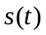 can be described as [7]
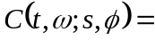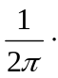
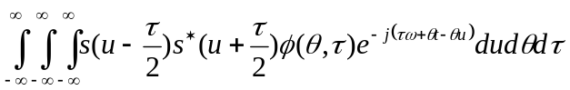.
A TFD 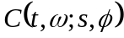 can be interpreted as the energy distribution of the signal in time () and frequency (), where 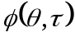 is referred to as the time-frequency kernel and can be chosen to suit the requirements of a given application[7].
A given member of Cohen’s class of TFDs possesses a time-shift covariance property if a time-shift of any signal causes the same shift of its TFD in the time direction. Similarly, a TFD possesses a frequency-shift covariance property if a frequency-shift of a signal causes the same frequency-shift of its TFD.
Time- and frequency-shift covariances can be used to obtain time- and frequency shift invariant representations of TFDs, which is often useful for enhanced time-frequency pattern recognition [8], [9]. As we have found that frequency-shift of a TMJ sound carries important information, frequency-shift invariance will not be discussed in this paper.
Time-shift covariance of a TFD can be used to get its time-shift invariant representation through the autocorrelation of a time-shift covariant TFD in the time direction. In [9] another way of employing time- and frequency-shift covariance to achieve respective invariant representations was presented. A time-shift covariant TFD was viewed as a two-dimensional (2D) probability distribution function (pdf) and its time-shift invariant representation 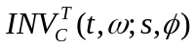 was achieved as
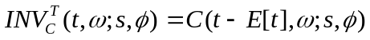 (1)
where 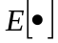 denotes a mathematical expectation operator regarding as a 2D pdf.
Scale covariance property of a TFD 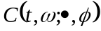 can be mathematically expressed as
. (2)
Scale covariance can be employed to obtain a scale invariant representation of a TFD using the scale transform. Scale transform was introduced by Cohen [10] and for a given signal it is defined as
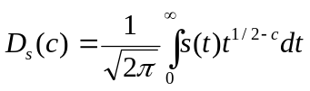
where is a real number referred to as the scale value. One can easily show that the absolute value of the scale transform of a scaled signal 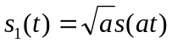 is the same as the one of the original signal . This property can be exploited to achieve a set of scale invariant features of a scale covariant TFD by performing a scale transform along its time and frequency axes for different pairs of scale values.

2.2. Feature Extraction
As RIDs are a time-shift and scale covariant class of TFDs [4], scale and time-shift invariant representations (STIRs) of RIDs can be obtained through autocorrelation of the RID in time direction and a scale transform for different pairs of scale values along the time lag and frequency axes of the previously obtained energy-normalized autocorrelation matrix [8]. This procedure yields a STIR feature for each pair of scale values, which is very useful when comparing, RID entries of different sizes.
In [9] a RID is seen as a 2D pdf and its time-shift invariant representation (TIR) was achieved using equation (1). Feature extraction can in this case be done using the concept presented in [11]. It is well known that for each 2D random variable 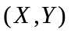, its characteristic function 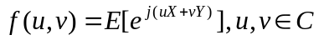 uniquely describes the corresponding pdf. Furthermore, provided that all the moments 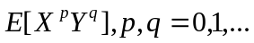 exist, characteristic function 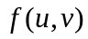 can be completely described by these moments [7].
The TIRs of RIDs obtained using equation (1) can be viewed as discrete 2D pdf-s with a finite support in both time and frequency directions. Therefore, all their moments exist and each invariant representation is uniquely and completely described by the corresponding set of moments 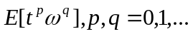 A selection of moments can be made so that most of the relevant information from the RID is retained, and can be used in subsequent pattern recognition.

2.3. Pattern Recognition
The Nearest neighbor (NN) pattern recognition method is simple and intuitively very appealing. A query item of unknown origin is assigned to a class of the training item least distant from the query object. Nevertheless, representational capabilities of the NN method are limited. Therefore large training sets are often needed for a successful classification. Using linear combinations of training items may be a way to increase the representational capabilities of the training set [12].
A query item can be assigned to the class such that its training items span a linear subspace that is closer to that particular query item than any of the linear subspaces spanned by training items from other classes. Orthogonal distance from a query item represented by a vector 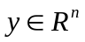 to the linear subspace formed by the training items represented by vectors 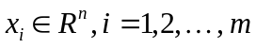, where 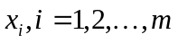 are linearly independent, can be accomplished using a well known singular value decomposition (SVD) [13]. SVD of the matrix 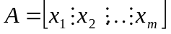 yields an orthonormal basis such that the first basis vectors belong to the linear subspace spanned by the vectors , and the remaining vectors span the subspace orthogonal to and will be referred to as the zero subspace. Orthogonal distance from to the linear subspace spanned by is equal to the norm of the projection of onto the zero subspace obtained through the SVD of matrix  [8]. Pattern recognition method corresponding to this procedure will be referred to as the zero subspace (ZSS) method [8], [9].
The distance from a query item to a given class is computed as the orthogonal distance from that item to the subspace spanned by constrained linear combinations of training items from that class, and subsequently be assigned to the nearest class [12]. The set of constrained linear combinations of vectors 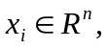 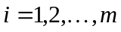 is described as 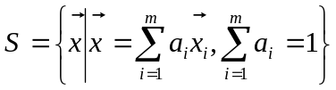 [12]. The distance from a given vector to the subspace is equal to the distance between the vector 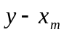 and the linear subspace spanned by linear combinations of vectors 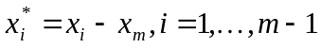. Hence, provided that vectors 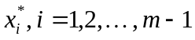 are linearly independent, the orthogonal distance from to can be assessed using the same SVD based technique as described above. This pattern recognition method was recently introduced in [12] and was referred to as the nearest constrained linear combination (NCLC) method.

RESULTS
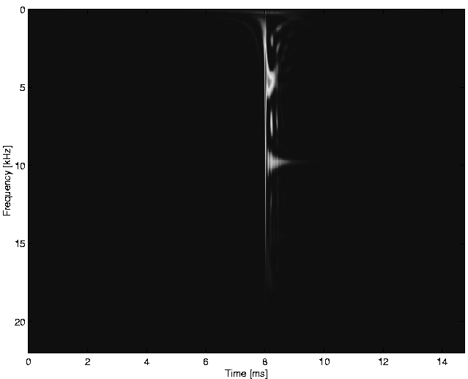
The experimental group consisted of four subjects. Sounds evoked from the TMJs during jaw opening-closing movements were digitally recorded with the sampling frequency 44.1kHz. The recordings were windowed using a 512 points Hanning window and processed into RIDs using the binomial kernel [4].
A total of 68 sounds was gathered from subject #1, 39 sounds from subject #2, 54 from subject #3 and 3 from subject #4. Regrettably, we were not able to collect more sounds from subject #4, but as these sounds showed a typically high frequency content, they were included into database. Subject #1 displayed a striking repeatability of TMJ sounds, generally characterized as sounds with well localized, short duration RIDs with a low frequency content and a single energy peak located at around 270Hz. Subject #2 displayed sounds with rugged RIDs having several energy peaks in the frequency region below 3000Hz. Sounds originating from subject #3 were characterized by either rugged RIDs with the energy located below 2000Hz, or by well-localized RIDs with a single energy peak located at frequencies below 1200Hz. All sounds from subject #4 had a characteristically high frequency content with a significant energy content in the range up to 22000Hz. Figures 1 and 2 show RIDs of typical sounds evoked by the four subjects.
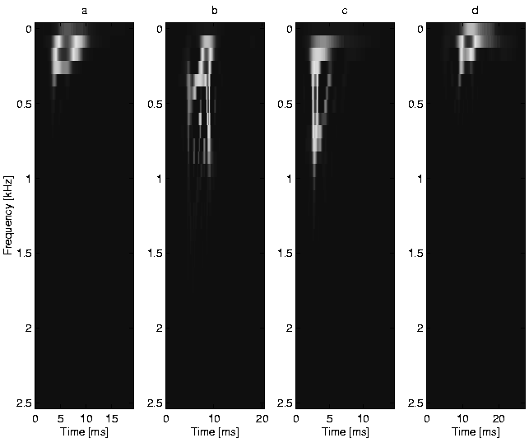
Fig.1. Reduced Interference Distributions of typical TMJ sounds evoked by subjects #1 (a), #2 (b) and #3 (c and d)
Fig.2. Reduced Interference Distribution of a typical TMJ sound emitted by subject #4.
Tables 1, 2, and 3 show the performance of the NN, ZSS and NCLC classifier, respectively, using STIR features of the RIDs of TMJ sounds. STIR features were computed for scale pairs from the set 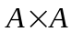, where 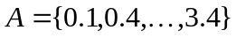. Entry in the i^{th} row and j^{th} column shows the percentage of sounds emitted by subject #i that were assigned to subject #j. Performance was averaged over five different training sets containing 82 TMJ sounds, while the remaining 82 sounds were used for testing. Overall success rates of the NN, ZSS and NCLC classifiers were 96.10%, 90.73% and 93.17%, respectively.
Tables 4, 5 and 6 show results of the NN, ZSS and NCLC classifiers, respectively, using moments of order up to 15 of the TIRs of the RIDs as features (order of the moment 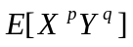 is 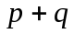). Performance was averaged over the same five training sets as in the case in Tables 1, 2 and 3 and entry in the i^{th} row and j^{th} column shows the percentage of sounds emitted by subject #i that were assigned to subject #j. The overall success rates of the NN, ZSS and NCLC classifiers were 97.8%, 90.98% and 97.56%, respectively.

5. DISCUSSION
From Tables 1 and 2 it is possible to notice that NN and ZSS classifiers of STIRs were not successful in recognizing subject # 4, even though the sounds seemed to be very different from the sounds from the other subjects (extremely high frequency content). The reason for this behavior is scale invariance which, when invoked, may cause items with significantly different frequency contents to have similar STIRs due to inverse scaling described by equation (2), which connects the original and scaled RIDs.
All TIR classifiers also had a high success rate, but were able to distinguish a high frequency sound coming from subject number 4 from the rest of the sounds. The reason is that in this case, scale invariance is omitted and the high frequency sounds from subject #4 are easily distinguishable.
Table 1. Performance of the NN classifier using STIR features of the RIDs.
100 | 0 | 0 | 0
0 | 85.71 | 14.29 | 0
0 | 0 | 100 | 0
0 | 37.5 | 37.5 | 25

Table 2. Performance of the ZSS classifier using STIR features of the RIDs.
100 | 0 | 0 | 0
4.29 | 54.29 | 41.43 | 0
0 | 0 | 100 | 0
0 | 0 | 75 | 25

Table 3. Performance of the NCLC classifier using STIR features of the RIDs.
100 | 0 | 0 | 0
12.86 | 74.29 | 12.85 | 0
9.71 | 0 | 90.29 | 0
0 | 0 | 0 | 100

Table 4. Performance of the NN classifier using TIR moments of the RIDs.
100 | 0 | 0 | 0
0 | 91.43 | 8.57 | 0
0 | 3.00 | 97.00 | 0
0 | 0 | 0 | 100

Table 5. Performance of the ZSS classifier using TIR moments of the RIDs.
88.21 | 0 | 11.79 | 0
0 | 85.71 | 14.29 | 0
0 | 0 | 100 | 0
0 | 0 | 0 | 100

Table 6. Performance of the NCLC classifier using TIR moments of the RIDs.
100 | 0 | 0 | 0
0 | 95.71 | 4.29 | 0
6.8 | 0 | 93.2 | 0
0 | 0 | 0 | 100

It should also be noted that we were able to achieve a training set containing 82 items that yielded perfect performance of the NN classifier both with TIRs and STIRs. Careful training with large sets from all subjects may yield better performance of the other classifiers too.

6. CONCLUSIONS
There is reason to believe that TMJ sounds differ between patients because of differences in degree or type of TMJ pathology/dysfunction. The results show that it is possible to associate TMJ sounds to the joints where they were evoked, using time-frequency analysis and robust pattern recognition methods. The method described may therefore be used for inexpensive and objective TMD diagnoses if further developed after obtaining training sets from people with confirmed TMD diagnoses. Further research is motivated to develop TMJ sound analysis for reliable use in TMD diagnosis.

7. REFERENCES
- Widmalm, S. E., Westesson, P. L., Brooks, S. L., Hatala, M. P. and Paesani D. Temporomandibular joint sounds: Correlation to joint morphology in fresh autopsy specimens. American Journal of Orthodontics & Dentofacial Orthopedics, 101, 1992., pp. 60 - 69.
- Widmalm S. E., Williams W. J., Christiansen R. L. Gunn S. M. and Park D. K. Classification of Temporomandibular Joint Sounds Based Upon Their Reduced Interference Distributions. Journal of Oral Rehabilitation, 23, 1996., pp. 35-43.
- Brown M. L., Williams W. J. and Widmalm S. E. Automatic Classification of Temporomandibular Joint Sounds. The Artificial Neural Network in Engineering Conference, 1994., pp. 725-730.
- Williams W. J. and Jeong J. Reduced Interference Time-Frequency Distributions. Time-Frequency Signal Analysis; Methods and Applications, Ed. B. Boashash, Longman Cheshire, 1992. pp. 74-97.
- Yoo S., Boston J. R., Rudy T. E., Greco C. M. and Leader J. K. Time-Frequency Analysis of Temporomandibular Joint Sounds. Proc. Time-Frequency and Time-Scale Symp., 1998., pp. 289-292.
- Yang K. P., Djurdjanovic D., Koh K. H., Williams W. J. and Widmalm S. E. Automatic Classification of the Temporomandibular Joint Sounds Using Scale and Time-Shift Invariant Representations of Their Time-Frequency Distributions. Proc. Time-Frequency and Time-Scale Symp., 1998., pp. 265-268.
- Cohen L. Time-Frequency Analysis. Englewood Clifs, NJ: Prentice-Hall, 1995.
- Williams W. J., Zalubas E. J., Nickel R. M. and Hero III A. O. Scale and Translation Invariant Methods for Enhanced Time-Frequency Pattern Recognition. Multidimensional Systems and Signal Processing, 9, 1998., pp. 133-141.
- Zalubas E. J., O’Neill J. C., Williams W. J. and Hero III A. O. Shift and Scale Invariant Detection. Proc. IEEE-SP Int. Conf. On Acoustics, Speech and Signal Processing, 5, 1996., pp. 3637-3640.
- Cohen L. The Scale Representation. IEEE Trans. Sig. Proc., 41, 1993., pp. 3275-3292.
- Tacer B. and Loughlin P. Time-Frequency Based Classification. SPIE Proc., 2846, 1996., pp. 186-192.
- Li S. Z. Face Recognition Based on Nearest Linear Combinations. Proc. IEEE Conf. on Computer Vision and Pattern Recognition, 1998., pp. 839-844.
- Dewilde P. and Deprettere E. F. Singular Value Decomposition, An Introduction. In “SVD and Signal Processing, Algorithms, Applications and Architectures,” Eds. Deprettere E. F., Elsevier Science Publishers B.V. (North Holland), 1988., pp. 3-41.

